Introduction
Confucius said, “To eat coarse greens, drink water, and crook one’s elbow for a pillow, joy also lies therein. Wealth and high rank obtained by unrighteous means are to me like the floating clouds.” Le, which is translated to joy, is inherent in Confucius’ mundane life. Even though he was forced to resign his post and go into exile, he still perceived a strong sense of Le and pursue his highest good. And this sense of Le would be regarded as a form of happiness.
Happiness is an elusive concept. Individuals living with different time period and cultural background would give different connotations toward happiness(Oishi et al., 2013). From Confucius, we can perceive a common sense of internal enrichment. This sense of happiness is highly in accordance with superior happiness in the greatest happiness principle, which far exceeds the satisfaction receive from physical sensation. However, similarly, both sense of happiness blend inseparably with the simple physical sensation, turning into distinctive forms that exceeds corporal restriction (Riley, 2013).
Based on this understanding toward happiness, which reinforces on eudamonic happiness but not exclude hedonic happiness, this essay will argue that happiness cannot be measured in subjective well-being test (SWB) (Stone et al., 2013).
The logic of measuring happiness is similar to the logic of Plato’s theory of form--the idea of a perfect circle can only exist in its form, but doesn’t exsit in reality. Similarly, people can only measure specific aspects of life to approach happiness, but the real happiness only exsits in perception, not exsit in subjecitive measurable form.
To prove my claim, I will adopt the logic of “Four Fields of Knowledge” to illustrate the barriers of subjective measurement (Schumacher, 1978). An effective measurement of self-evaluated happiness must take two processes:
- Respondents have a clear understanding toward their inner life’s happiness (I - inner)
- They convey their sense of happiness accurately and completely to outer life (The world-inner)

Process 1
Lack realization toward inner life
In Tao Te Ching, Lao-Tzu believes that “ He who knows himself is enlightened.” Knowing oneself is largely contribute to the state of happiness, but to achieve knowing, one needs to be fully self-awared (Schumatcher). By invoking system II (Kahneman, 2011) and metacognition, human beings can explore their inner thoughts more thoroughly. However, from evolutionary perspective, the activation of system II requires an input of energy, and human beings have natural tendency to conserve energy (Kahneman, 2011). Moreover, people are likely to direct their divided attentions to external environment. Corteen and Wood (1972) discovered that even when words didn’t consciouslly perceived by participants, they still established meaning. Therefore, without directing attentions fully to the process of thinking, it would be uncertain whether a man knows him.

Moreover, even if a being believes that he knows whether he perceive a sense of happiness or not, it may not be the truth. To illustrate this claim, I adopt the Tal Ben-Shahar’s (2007) model and analyze the insufficiency of realizing happiness under each archetypes. For every individual has a belief toward present happiness and future happiness, he/she can fill into a quadrant.

Hedonism
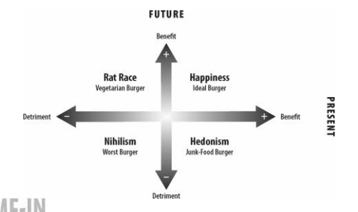By taking psychoactive drugs and performing religious behaviors, human beings can intentionally alter their states of consciousness (Cacioppo & Freberg, 2019, p. 215). With this artificial change of beliefs, hedonistic drug takers regard instant satisfaction as meaning and happiness and disregard their future. However, if the real happiness approaches the end of eudamonia, the overall achievement in life is used to assess happiness according to Aristotle. Therefore, hedonists may mistakenly believe they already gain ultimate happiness but virtually they are far it.
Overall achievement--needs further clarification, even include the events after death.[ oxford handbook of happiness]

Nihilism
During the World War II, numerous people failed into learned helplessness and believed that they loss both present and future happiness. According to Karl Jasper’s theory, they fail into a “limit situation”, beliving that only external locus of control exsit (Valdes-Stauber, 2016). However, limit situation also “becomes one’s destination in the realisation of one’s exisence”, provoking people to ask deep happiness (Jacobsen, 2008, p. 37). Frankl (2006, p. 137) accept his unavoidable sufferings bravely, believing potential meaning is inherent in it. People with serious chronic diseases learn to adapt their impairments, redempting and transcending themselves (Charmaz, 1995). Thus, nihilists fail to see the integration between pain and happiness, disregarding the potential of transitoriness. If nihilists evaluate their happiness based on their “existence” rather than their “essense”, they fail to realize the true perception (Sartre, 1946).

Happiness
Happiness perceived by the former group converges with the definition adopted in this essay, but two main barriers hinder the group to measure inherent worthiness accurately. First, due to affect heuristic, people have natural tendency to make decisions and predictions based on state at that moment. Experiment also demonstrates that people living in momentarily peaceful state are more likely to report high satisfaction toward their entire life (Schwarz & Clore, 1983). Therefore, respondents who may not be happy in the future still report that he will experience happiness right now, which leads to a bias (再加一段?)

Rat Racer
Rat racers “subordinate the present to the future” and “suffer now for the purpose of some anticipated gain” (Tal Ben-Shahar, 2007, pp. 29–30) . Thus, they are likely to believe that their sacrfice in present happiness is meaningful. However, this destiny orientated purtsuit ignore the impact of the shift in reference points. Under this “finite game” (which is played for the purpose of winning)(Carse, 2012), rat racers keep aiming for a higher reference point and leave themselves in state of loss. Due to loss aversion, same amount of gain from the past and loss from now cannot subjectively offset each other (Kahneman, 2011). Ultimately, rat racers accumulate the loss continuously and the “anticipated gain” rarely bring them a sense of meaning.
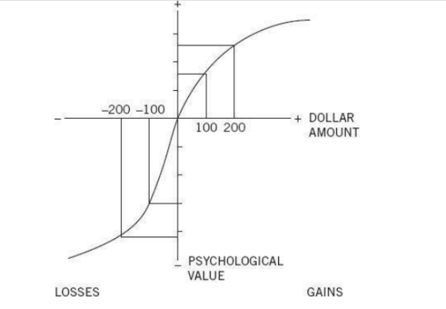

The second process reinforces on the interaction between internality and externality. To ensure the second process proceeds successfully, two conditions need to be satisfied:
2.1)Individuals are willing to convey their understanding toward externality fully and accurately
2.2)externality construct a frame that is able to capture individuals’ understanding fully

For 2.1 condition, intension for the test can strongly affect individuals’ willingness. If the test aims to achieve externality’s purpose, such as collecting data for scientific research, moderate anonymity facilitate collection of more authentic report by lowering social desirability pressures (Lelkes et al., 2012) However, if the respondents regard the measurement as a way of knowing himself, one main question will rise: can a man be honest to himself even when he is alone?

The existence of cognitive dissonance can undermine respondents willingness to convey their understanding accurately. For rat racers, reporting a high level of happiness (action) allows respondents to stay consistent with social expectation of wealth and fame (belief), even though they realize the lack of happiness. Moreover, under the value system that “unhappiness is a symptom of maladjustment” (Frankl, 2006b, p. 136), respondents may hide their willingness more to conform social desirability and to reduce their cognitive dissonance .

Since the concept of meaningful happiness varies among individuals, questions in the subjective measurement need to ensure all respondents’ understandings are included (Steger et al., 2006). However, that also means the adopted defintion is not precise and thus the measurement is highly dependent on respondents’ understanding. If the first condition fails, the second process will hard to be achieved.

On the other hand, making the test more concrete will bring more challenges. Firstly, sources that promote happiness are hard to be discovered. Stone et al. (2013) illustrates that testing “nonhedonic sources of happiness and suffering” in questions can improve the evaluation of eudamonic wellbeing. However, I suggest that whether these sources promote happiness is highly dependent on circumstances. For instance, confronting a challenge successfully can bring competence, which is normally considered as a promoter of happiness, but if there is a lack of autonomy, respondents still perceived a lack of intrinsic motivation and thus hard to enhance their happiness (Ryan & Deci, 2000). Therefore, if the measurement improve the evaluation by incorporating more correlated sources, it needs to take strongly correlated factors comprehensively.

Secondly, an illustration toward meaningful is strongly limited by the cognition of society. Influenced by culture, measurement in collectivism society will attach more importance on contribution toward group, likely to regard these efforts are more meaningful than personal growth.

Also, in a specific era, society can hardly understand individuals’ happiness. In Tang dynasty, Su Tungpo spoke truth to power and thus was exiled to barbaric land such as Lingnan. Even though he was aged and could not reunion with his family members, he still perceive a strong sense of happiness, expressing that in his poem: “with three hundred litchis every day and night; I am willing to be a Lingnan man for the rest of my life.” (Lin, 2018) The society aimed to suppress him and reduced his happiness, but Tungpo “amor fati” (Han-Pile, 2009). This diverged interpretations toward happiness between individual and society means if the externality construct a measurement, it would hardly be not biased.

More importantly, individuals can hardly falsify that society and individual have diverged understanding toward happiness under the pressure of mainstream culture. From Confucian era to now, society regards the connection with externality is essential, which can be shown by the encouragement of participating politics and attachment on interpersonal relationship (Confucius, 2019). Maslow also illustrates that the development of self-esteem needs an interaction between others and the individual (Maslow, 1943). It is convincing that healthy relationship with externality promotes one’s happiness, but is it possible that society overly reinforces the role of externality on one’s happiness? Under this meanstream culture, individuals original understanding toward happiness alters and seems to converge with society’s understanding. What they lose is that they can hardly discover their intrinsic understanding under the social frame.

